

IS602 Spreadsheet Modelling for Water Supply
Final Report: Group 7

Prepared by:
Chen Yingxin
Cheng Ho Wang
Lam Nguyen Thanh Thao
Wu Jiayan
Wong Teck Kiong

Problem Introduction
Singapore’s water security is a cornerstone of its long-term sustainability and economic resilience. The nation currently relies on the “Four National Taps” - local catchment water, imported water, NEWater, and desalinated water to meet growing demand (National Library Board, 2020). This integrated system has served the nation well for decades. However, as the population grows and the economy expands towards 2060, total water demand could nearly double (with the non-domestic sector accounting for about 70% of this demand) (PUB, 2025), raising questions over whether existing and planned supply capacities will be sufficient. Indeed, global assessments rank Singapore among the most water-stressed countries by 2040 (World Economic Forum, 2019), underscoring the seriousness of this concern. At the same time, climate variability like more unpredictable rainfall patterns and rising operational costs for weather-resilient sources like desalination add new layers of uncertainty to Singapore’s long-term water sustainability (PUB, 2023).
This project explores the hypothesis that “Singapore’s water supply is sufficient to support population and economic growth until 2060 under plausible supply and demand scenarios.” The study will also examine tariff and demand-management trade-offs that can sustain water security with an adequate safety buffer. Uncertainties include population growth rates, per-capita consumption trends, supply reliability, and the impact of tariff adjustments on water demand elasticity. By applying exploratory modeling and decision trade-off analysis in Excel, this study will help identify strategies that balance supply sufficiency, affordability, and resilience with the following objectives:
- Evaluate the sufficiency of Singapore’s total water supply under different population growth and consumption scenarios up to 2060.
- Build an Excel-based exploratory model simulating supply-demand balance under uncertainty.
- Analyze the impact of water tariffs on water consumption and supply-demand equilibrium.
- Perform sensitivity and trade-off analyses to test model robustness and policy implications.

Data Sources
The study leveraged publicly available datasets and official statistics which includes the list in Table 1
No | Data (Source) | Description | Purpose
1 | Population and growth forecasts  (Department of Statistics Singapore) | Annual population projections with baseline, low, and high population scenarios up to 2060. | For estimating future water demand drivers by multiplying projected population with per-capita consumption.
2 | Water demand and consumption trends  (PUB Annual Reports) | Historical and current residential water consumption data. | For deriving baseline and target consumption levels under different scenarios and calibrate elasticity-based demand reductions.
3 | Water supply capacities and projections  (Statista, 2024) | Annual sales of water by source - local catchment, imported, NEWater, and desalinated water. | For modelling National Taps’ supply capacity and project the composition of water sources through 2060.
4 | Climate and rainfall variability  (data.gov.sg) | Historical rainfall across Singapore from 2016 – 2024 | For modelling local catchment supply potential
5 | Water tariff history and structure  (data.gov.sg) | Data on water prices as at end of December each year, charged by 1,000 litres. | For analyzing water tariff-demand elasticity

Influence Diagram and Blackbox Model
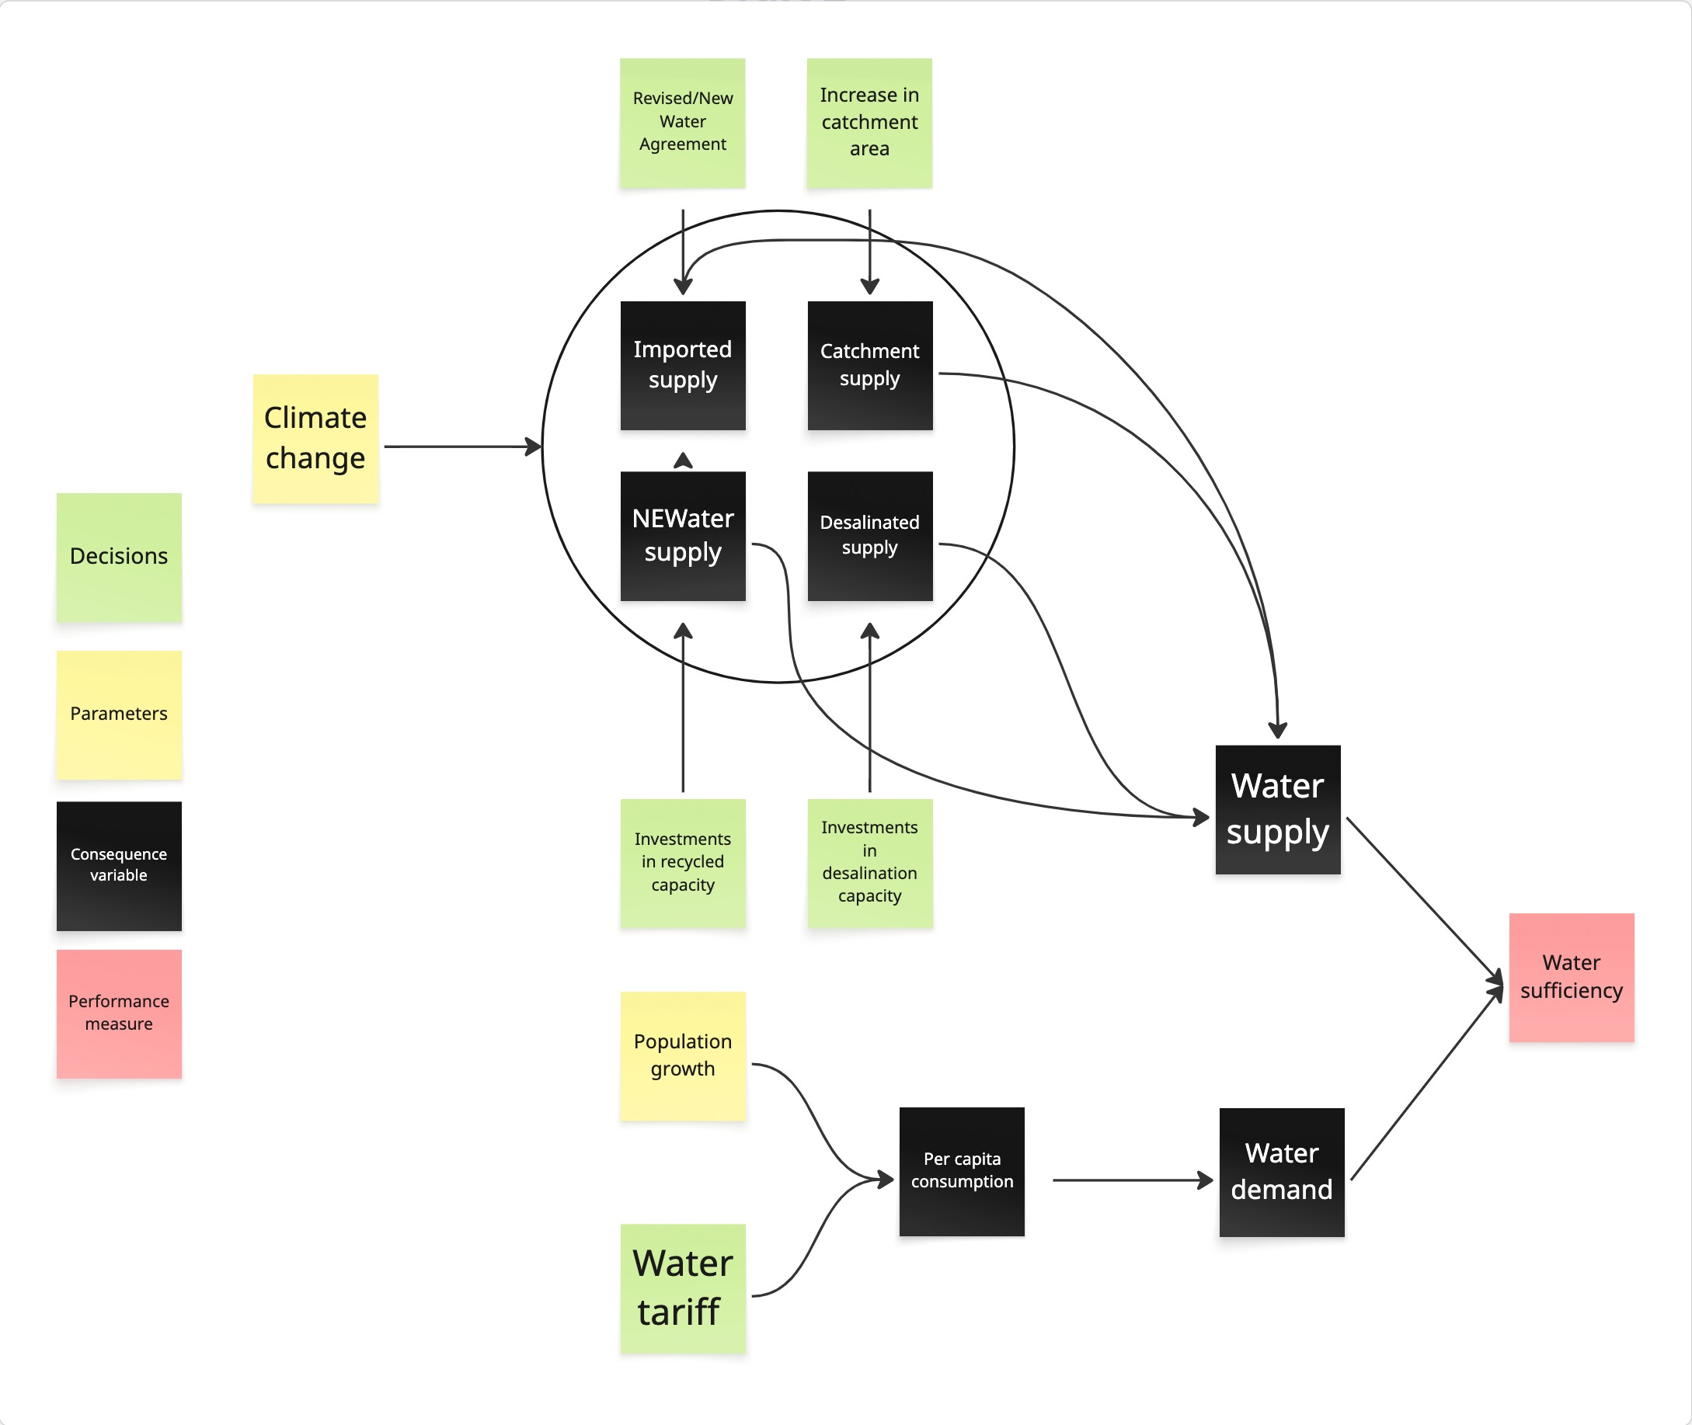
Figure 1 Influence Diagram for Singapore Water Tariff

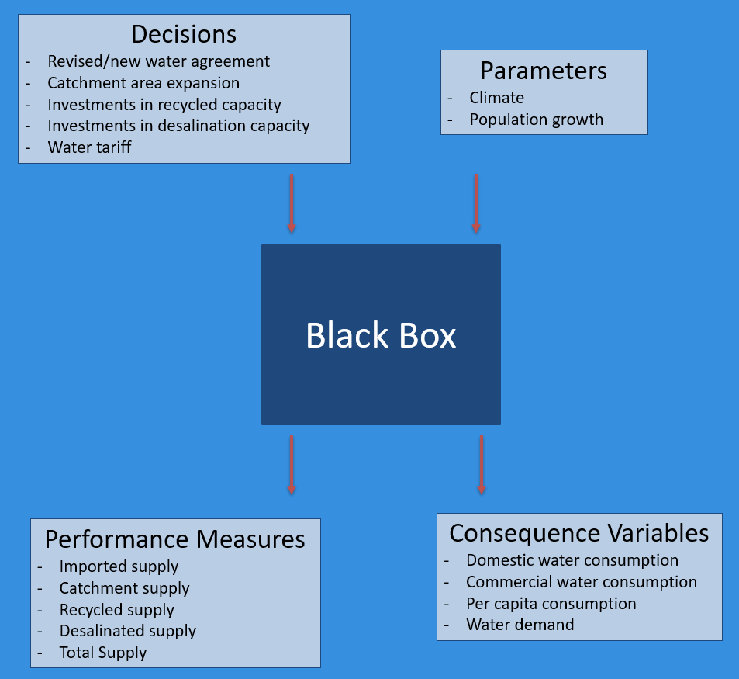
Figure 2 Black Box Model for Singapore Water Tariff

Model Computation and Analysis
Our spreadsheet models are the following: Total Water Supply - Total Water Demand
With the above framework, our model estimates:
- Till 2060, whether Singapore has sufficient water supply to meet demand
- The magnitude of any supply-demand gaps through 2060
- The impact of policy interventions on water security (water tariff)
Each of the sub-components has been explained in further detail below.
- Population
Population growth is the primary driver of water demand in Singapore. As seen in the historical data from 2000-2025, increasing population correlates strongly with rising water consumption. The model uses population projections as the foundation for demand forecasting.
We completed the following steps:
- Used historical population data (2000-2025) with Excel FORECAST functions to project population through 2060, including confidence intervals for uncertainty analysis
- Incorporated uncertainty analysis with confidence intervals: upper bound (+5%) and lower bound (-5%) around the central forecast.
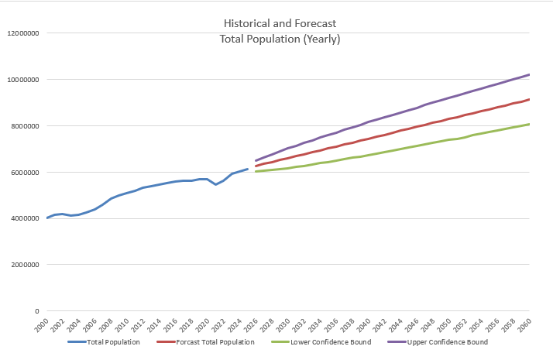
Figure 3 Historical and Forecast Total Population (Yearly)
- Per Capita Consumption
Per capita water consumption trends reflect Singapore's ongoing water conservation efforts. Our model projects future consumption patterns based on historical data. We completed the following steps:
- Used historical per capita consumption data (2013-2022) with Excel FORECAST functions to project future consumption through 2060
- Incorporated uncertainty ranges with lower (-5%) and upper bounds (+5%) around the central forecast
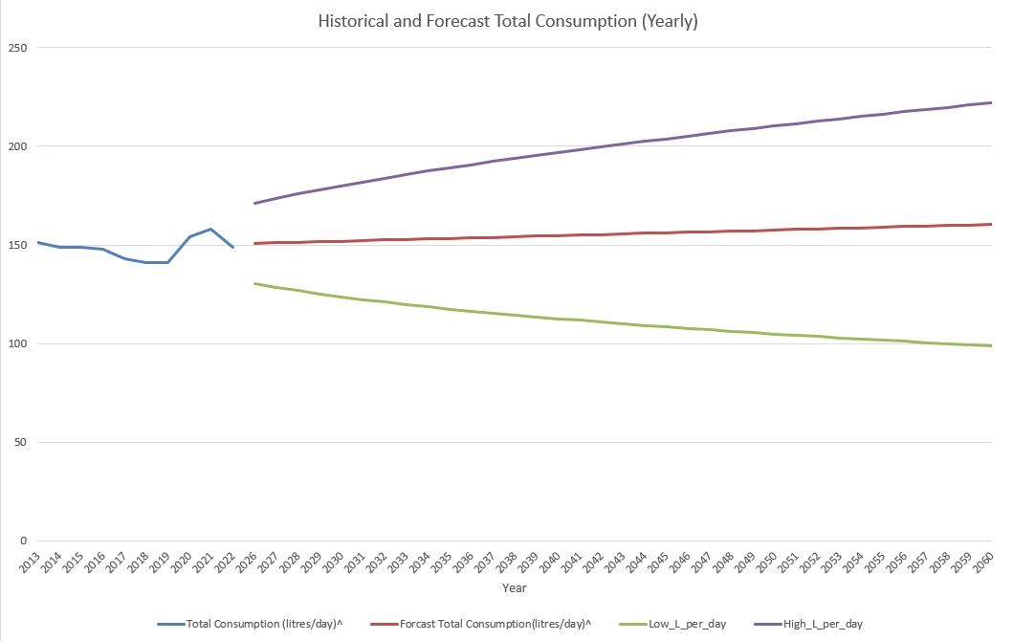
Figure 4 Historical and Forecast Water Consumption (Yearly)
- Tariff-Elasticity Adjustment
Water tariffs influence consumption behavior through price elasticity. Our model incorporates this relationship to simulate how pricing policies can manage water demand.
- Applied a price elasticity coefficient of -0.2, meaning a 10% tariff increase typically reduces consumption by 2%
- Used the formula: Adjusted Consumption = Base Consumption × (1 + Elasticity × Tariff Increase %)
- Modeled annual tariff adjustments and their cumulative impact on water consumption patterns
- This approach allows simulation of how strategic tariff policies can help manage demand growth while maintaining essential water needs
The results are visualized in the Adjusted Consumption (L per day) graph, which shows how consumption patterns evolve under different tariff scenarios through 2060.
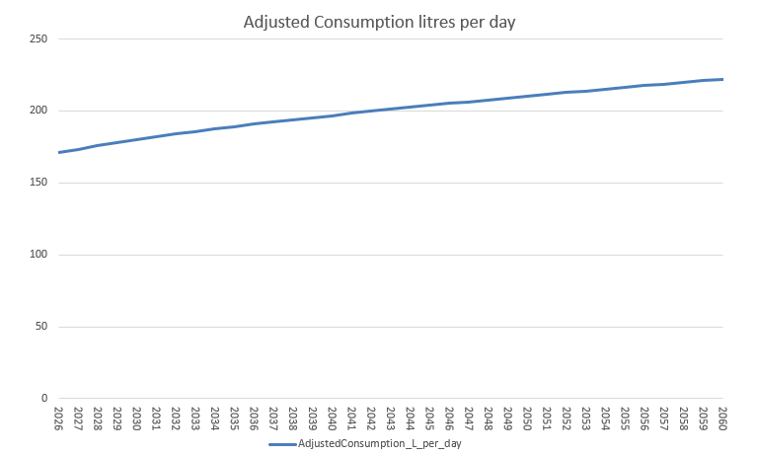
Figure 5 Adjusted per Capita Water Consumption
- Water Supply
Total water supply is modeled as the sum of four sources, ensuring a diversified water system:
- Total Water Supply = Local Catchment + Imported Water + NEWater + Desalination
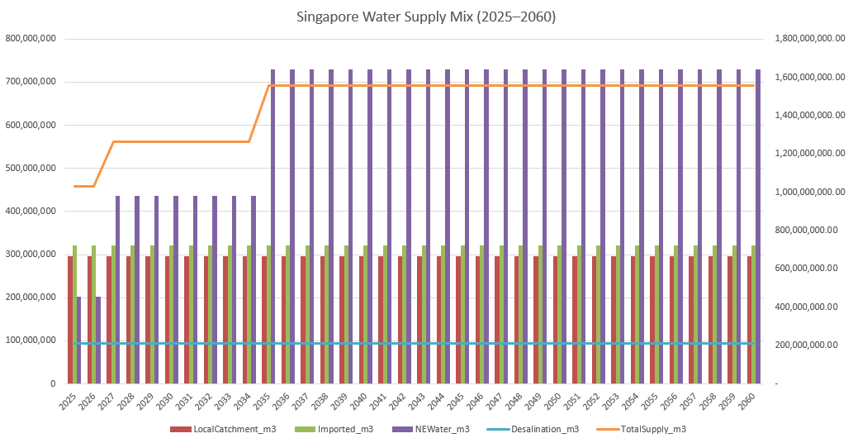
Figure 6 Singapore Water Supply Mix (2025–2060)
- Local Catchment Supply
Local catchment water supply is modeled based on rainfall patterns and collection infrastructure capacity, utilizing historical rainfall data (1982-2025) to project future availability.  - Formula: Catchment Supply = Rainfall × Catchment Area × Effective Yield Coefficient, where the effective yield coefficient (28.1%) represents the portion of rainfall that ends up as usable reservoir supply after accounting for run-off and storage efficiency.  - The model incorporates inter-annual rainfall variability (≈20.5%) derived from historical dataset, simulated through a lognormal distribution to ensure that rainfall - and thus supply- remains non-negative. The σ parameter for this distribution is computed as  σ = SQRT(LN(1 + CV²)), where CV is the coefficient of variation (year-to-year rainfall variability). | 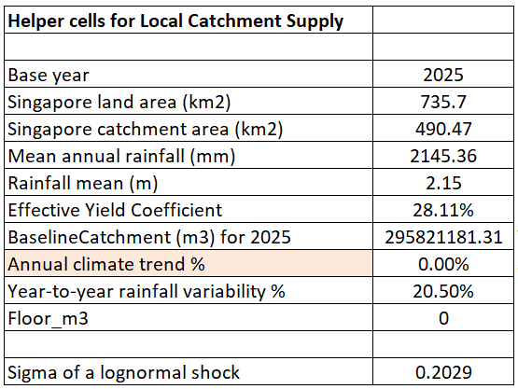  Figure 7 Helper cells for Local Catchment Supply
By default, the annual climate trend is set to 0%, assuming no long-term drying or wetting trend, though this can be toggled to test scenarios such as −0.25% per year to reflect climate change effects such as gradual drying. The results show that the modeled local catchment supply follows rainfall fluctuations while remaining stable overall, reflecting the resilience of Singapore’s reservoir and drainage system.
- Imported Water Supply
Imported water from Malaysia is modeled under the 1962 Water Agreement, which allows Singapore to draw up to 250 million gallons per day (mgd) from the Johor River until 2061. The model incorporates reliability and contractual constraints to capture operational uncertainties. | 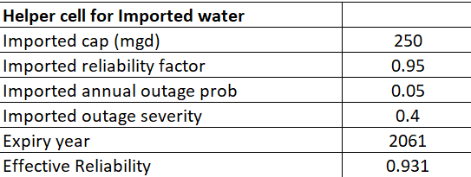  Figure 8 Helper cell for Imported water
- Assumption: In any given year, there is a 5% chance that imports are partially curtailed by 40% for a meaningful period (not the entire year), reflecting possible river-level or water quality issues, infrastructure faults, or cross-border constraints. To simplify this uncertainty, we model it as a single Bernoulli draw per year - each year either operates normally or experiences a partial curtailment event.
- Accordingly, the expected supply is calculated as:
Actual Supply = 250 × 365 × [0.95 + 0.05 × 0.6] × 1₍ₜ≤2061₎,
yielding an average of approximately 89,425 million gallons per year, or about 321 million m³/year.
- Incorporated agreement expiration logic terminating supply after 2061.
The results show consistent imported water supply of approximately 89,425 million gallons annually until 2061, after which supply ceases as visualized in the Imported Water Supply graph.
- NEWater Supply
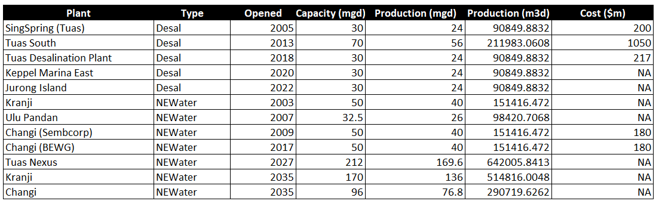
Figure 9 Plant (List of Desalination and NEWater Plants)
NEWater represents Singapore's advanced water recycling capability, providing a sustainable and climate-resilient water source through membrane filtration and reverse osmosis technology.
- Tracked existing and planned NEWater plants with their capacities and commissioning timelines
- Included expansion plans (Tuas Nexus in 2027, Kranji and Changi expansions in 2035) with projected capacity increases
- Applied capacity factor (80%) across plants to account for maintenance and efficiency
- Summed contributions from all operational plants each year using: Total NEWater Supply = Σ(Plant Capacity × Utilization Factor)

- Desalination Supply
Desalination provides Singapore with weather-resilient but energy-intensive water through reverse osmosis of seawater, serving as a reliable source independent of rainfall patterns.
- Modeled existing desalination plants and planned expansions through 2060
- Applied capacity factor (80%) across plants to account for maintenance and efficiency
- Summed annual contributions using: Total Desalination Supply = Σ(Plant Capacity × Availability Factor)

- Model Core: System balance & reliability
Next, we aggregate total water demand and supply for each year and convert them into an adequacy indicator that tracks whether Singapore maintains a sufficient buffer between available supply and demand. Total demand is composed of two parts: domestic and industrial consumption.
- Domestic demand is driven by population and per-capita use with proper unit conversion from litres per person per day into annual cubic metres:
DomesticDemand_{t} = Population_{t} × PerCapita(L/person/day)_{t} × 365 / 1000 (m³/yr)
- Industrial demand evolves with Singapore’s economic mix. In our base, we let the industrial share rise over time. To capture this structural change, we introduce a variable called IndShare, representing the share of industrial water use as a fraction of total demand. The implemented formula scales domestic demand with a time-varying factor.
IndustrialDemand_{t} = DomesticDemand_{t} × [ IndShare_{t} / (1 − IndShare_{t} ) ],
where IndShare_{t} increases linearly from ~55% (2025) toward 70% (2060).
Then, total demand is calculated as the sum of domestic demand and industrial demand.
Similarly, we computed total supply as the sum of the four taps: Local Catchment, Imported, NewWater and Desalination. The reserve margin, our primary adequacy indicator is calculated as below:
ReserveMargin_{t} = TotalSupply_{t} / TotalDemand_{t − 1}
If the reserve margin has positive values, it indicates buffer; otherwhise negative values indicate shortfall. We also monitor the net balance using this formula:
NetBalance_{t} = TotalSupply_{t} − TotalDemand_{t}
- Trade-off Analysis
In this section, we extend the balance model into a policy optimization problem that tests how much tariffs must rise to maintain Singapore’s water security through 2060. The question addressed here is: what is the smallest average tariff increase that still ensures the system remains reliable every year, under a chosen demand scenario?
Users first select the Population Scenario and Consumption Scenario (Baseline / Low / High), which feed directly into the demand calculations but are treated as parameters, not decision variables. The decision variables in this stage are the annual tariff increases from 2026 to 2060. Solver iteratively adjusts these tariff percentages and propagates the effects through the tariff elasticity link in the tariff modelling sheet, which modifies per-capita consumption and, in turn, annual water demand in Model_Core sheet.
Objective. The optimization objective is to minimize the average annual tariff increase between 2026 and 2060. In practice, Solver searches for the gentlest possible upward tariff trajectory that still satisfies all policy and technical constraints.
Decision variables. The decision variables are the annual tariff uplifts for 2026-2060 in sheet Trade-off Analysis. Solver will be used to adjust these percentages and the sheet propagates them through the elasticity link in the tariff modelling sheet (Inputs_Tariff), which updates per-capita use and hence annual demand in the core model (sheet Model_Core).
Constraints. Two key constraints govern the optimization:

Tariff floor. A minimum annual tariff increase is imposed so that no year’s adjustment falls below a policy threshold of 1.1%. This ensures tariff policy remains gradual but realistic and avoids setting unreasonably low increases that would fail to influence consumption behavior.

Security buffer. For every year, the reserve margin- the ratio of supply to demand minus one, must remain above a minimum level of 10%. This ensures that total available water supply stays at least 10% greater than total demand, preserving a safety buffer against uncertainties such as rainfall variability or import disruption.
Together, these components define a clear optimization problem: find the smallest average tariff increase that still keeps the reserve margin positive and above the safety threshold every year to 2060. Solver is run using a nonlinear optimization method, which adjusts tariff paths smoothly while ensuring that both economic (tariff) and physical (reserve margin) limits are respected. The resulting tariff trajectory provides policymakers with an economically efficient plan that maintains long-term water security across all population and consumption growth scenarios.
- Sensitivity Analysis
In this final stage, we test how sensitive the system’s water security is to changes in tariff elasticity, while keeping the optimized tariff path fixed. This analysis helps assess the robustness of the policy solution under different assumptions about how strongly consumers react to price changes. We hold the Population and Consumption Scenarios constant, and vary tariff elasticity (ε) in the demand equation:
AdjustedPerCapitaₜ = BasePerCapitaₜ × (1 + ε × TariffIncreaseₜ).
For each elasticity value, the model recomputes annual water demand, total supply, and the resulting ReserveMargin %, which measures the adequacy of supply over demand. The range of elasticity tested spans from −0.1 to −1.0, with −0.2 taken as the baseline. More negative values indicate stronger conservation response to tariff changes.
To implement this efficiently in Excel, we used the Data Table feature. The table is configured with elasticity values across the row and years down the column. For each combination, Excel automatically recalculates the ReserveMargin % using linked formulas from the core model. A secondary table then computes the margin change for a selected year, comparing each elasticity outcome to the baseline case (Δ Margin = ReserveMarginₜ(ε) − ReserveMarginₜ(−0.2)). The results are visualized through a horizontal bar chart that highlights how the reserve margin shifts as elasticity assumptions vary.
If the reserve margin increases as ε becomes more negative, it indicates that higher consumer responsiveness (elasticity) leads to lower water demand and stronger system security. Conversely, when the margin decreases under weaker elasticity (e.g., −0.1), the model signals potential shortfalls that would require either stronger tariff adjustments or expanded supply to maintain 10% safety buffer.
This one-way sensitivity analysis isolates behavioral uncertainty (price response) from policy choice (tariff path). It helps policymakers understand the reliability of the optimized plan: even if customers are only half as responsive to tariff changes as expected, Singapore’s water system would still maintain a sufficient reserve margin through 2060.

Results and Discussion
Our model projects Singapore’s total water demand to increase gradually from ~765 million m³ per year in 2026 to ~1.19 billion m³ per year by 2060, reflecting population and economic growth. Supply capacity is expected to rise sharply in 2027 and 2035, which coincides with the commissioning of new water reclamation plants, specifically the Tuas Nexus Water Reclamation Plant (2027) and the expansion of the Kranji and Changi plants (2035). These additions are expected to increase overall system capacity from about 1.03 billion m³ in 2026 to 1.57 billion m³ from 2035 onwards.

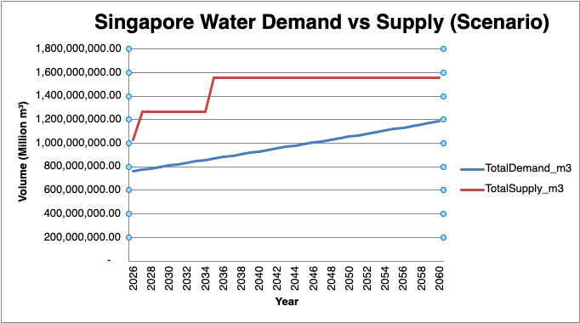
Figure 10 Singapore Water Demand vs Supply (Scenario)
Water Sufficiency and Buffer Trends
At baseline tariff levels (S$ 1.43 /m³), Singapore maintains a comfortable supply buffer through 2060.
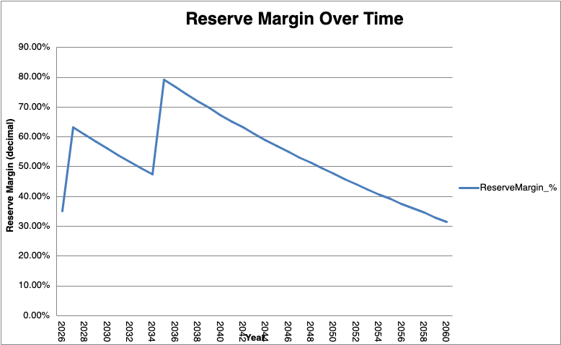
Figure 11 Reserve Margin Over Time

- Prior to 2027, the buffer is moderate (~34% in 2026), indicating reliance on existing desalination and NEWater capacities.
- Commissioning of Tuas Nexus boosts the buffer to >60% in 2027, ensuring strong resilience.
- Between 2028 and 2034, gradual demand growth reduces the margin to about 47%, but the 2035 expansions restore it to more than 70%.
- Thereafter, the buffer declines steadily to ~14% by 2060, as demand rises without corresponding new supply projects.

Despite the decline in buffer, the model shows no supply shortfall under the growth trajectory, supporting the hypothesis that Singapore’s water supply remains sufficient to 2060, provided that planned infrastructure is delivered on schedule and operated at high reliability.

Tariff and Demand-Management Considerations
The constant tariff of S$ 1.43 /m³ implies no change in price elasticity or consumption restraint. Sensitivity tests could explore tariff-linked demand moderation; even small price increases (e.g., +10%) can slow long-term demand growth by 1–2%, extending the post-2060 sufficiency horizon. Conversely, if population or industrial water intensity outpaces assumptions, the buffer could fall below 20% before 2060, triggering the need for either new desalination capacity or stronger conservation measures.

Implications
Maintaining a ≥30% buffer aligns with PUB’s security threshold for contingencies. To sustain this margin beyond 2060, Singapore could consider (i) further water reclamation expansion after 2035, and (ii) adaptive tariffs to manage per-capita use.

Conclusion and Recommendations
The exploratory model supports the hypothesis that “Singapore’s water supply will remain sufficient through 2060” under current infrastructure plans and moderate demand growth. Planned expansions at “Tuas Nexus (2027)” and “Kranji–Changi (2035)” provide large capacity boosts that preserve a comfortable safety buffer. However, as demand continues to climb, the buffer is expected to narrow by 2060, signalling the need for proactive planning beyond the mid-2030s.

To maintain long-term water security, Singapore should:
- Begin feasibility studies for next-generation desalination or NEWater expansion after 2035.
- Implement adaptive tariff mechanisms that reflect marginal supply costs and incentivise conservation.
- Invest in demand-side management such as water-efficient appliances, and behavioural nudges to flatten consumption growth.
- Integrate climate resilience by diversifying energy sources and recycling technologies.

These strategies ensure Singapore’s “National Taps” remain sustainable, resilient, and affordable beyond 2060.

References

- Department of Statistics Singapore. (2024). Population and population trends, Singapore [Dataset]. Data.gov.sg. https://data.gov.sg/datasets/d_3d227e5d9fdec73f3bcadce671c333a6/view

- National Library Board. (2020, August 19). Singapore’s four national taps: Securing our water future. Infopedia. https://www.nlb.gov.sg/main/article-detail?cmsuuid=71f07719-a200-4339-b20c-ec69e520776f

- PUB, Singapore’s National Water Agency. (2023, September 27). Water price to rise from April 2024; Government to provide support. Retrieved from https://www.pub.gov.sg/Resources/News-Room/PressReleases/2023/09/Water-price-to-rise-from-April-2024-Government-to-provide-support

- PUB. (2025). Singapore’s Water Loop - managing our water demand. PUB. Retrieved from https://www.pub.gov.sg/public/waterloop

- Statista. (2024). Annual sales of water in Singapore by type. https://www.statista.com/statistics/627100/sales-of-water-in-singapore-by-type

- World Economic Forum. (2019, August 21). Singapore: Innovation is key to securing its water future. Retrieved from https://www.weforum.org/stories/2019/08/singapore-focus-innovation-key-securing-water-future/

